Final Project
Togzhan Shaptayeva

SDA
CONTENTS

Purpose of document
Testing section
Testing checklist
Detailed test cases
Founded issues and bugs
Testing tools
Improvements
Test design techniques
Reflection

Purpose of documentation

To make sure the features of shein.com e-commerce webpage is working as expected.

Testing Section

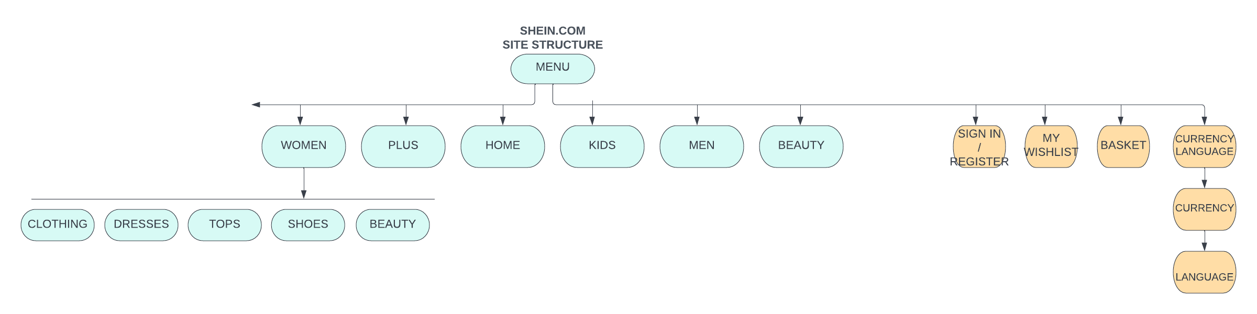

Shein.com is an e-commerce web page and main function is to sell goods, so in this diagram marked orange sections will be tested. I will check convenience and user friendliness of this web site. How comfortable to register, purchase goods, adding them to basket and wish lists and changing languages

Testing Checklist

Section | Unit | Requirements
UI | Main page | Check if the design is proper and error free
UI | Main page | If the images aligned properly
UI | Main page | Check if the advertisements don’t cover menu and buttons
Sign in/Registration | Sign in page | Check if the user is able to enter login and password
Sign in/Registration | Sign in page | Check if the user is able to enter invalid password
Sign in/Registration | Sign in page | if user gets some error messages when he enters wrong data
Sign in/Registration | Sign in page | Check if it is possible to log in with username, or email address, or phone number
Sign in/Registration | Sign in page | Verify if the data in password field is either visible as asterisk or bullet signs.
Basket | Items | Selected items should be reflected in the basket
Basket | Items | Verify that the user can add to cart one or more products
Basket | Items | Verify that the user can buy products added to the cart after signing in to the application (or as per the functionality of the website).
Basket | Items | Verify if the user can add or remove new items
Basket | Items | Verify if quantity of items change when add new item
Basket | Items | Prices of items should be shown
Basket | Items | Check if the price gets updated when the user adds and removes items
Currency /language | Currency | Check if you can open this section with one click
Currency /language | Currency | Check if section currency/language opens when user hovers on it without logged in
Currency /language | Currency | Check if the user can change currency
Currency /language | Currency | Check if the user can change language
Responsiveness | Screen | Website adjusts to the screen resolution in PC, mobile phone, tablets.
My profile | My Profile links | Verify if my profile link opens in new tab
My profile | My Profile links | Verify if my coupons link opens in new tab
My profile | My Orders | Verify if my orders section reflects all orders
My profile | Wishlist | Verify if my wishes section opens in new tab

Detailed Test cases

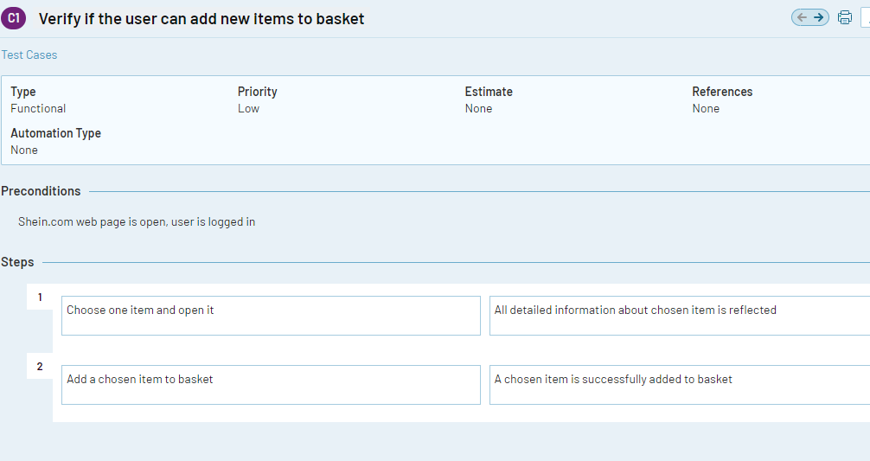
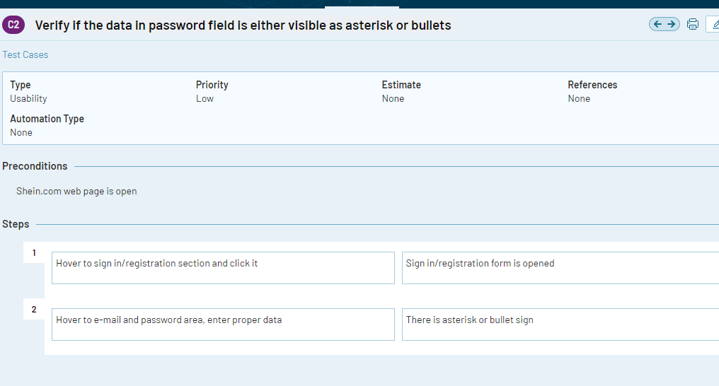

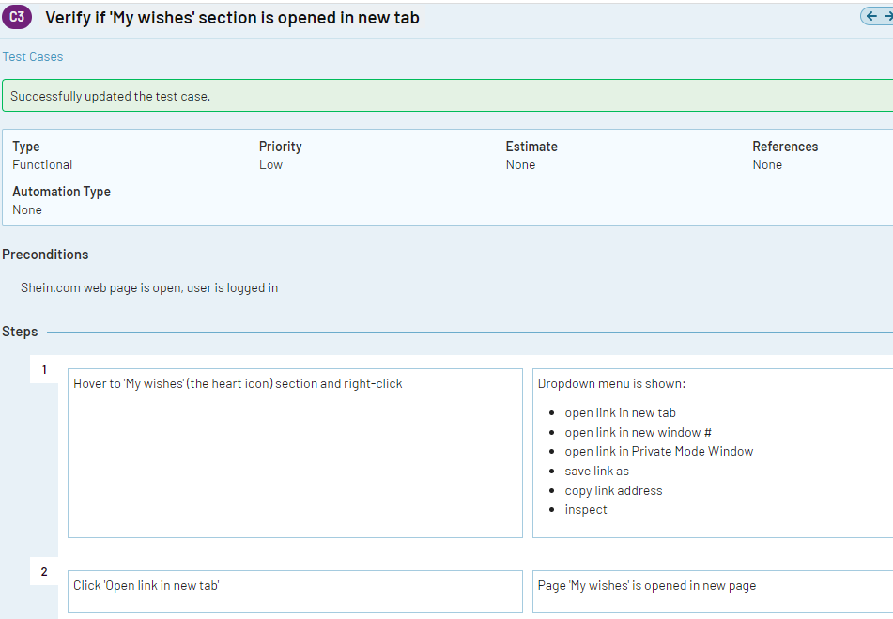

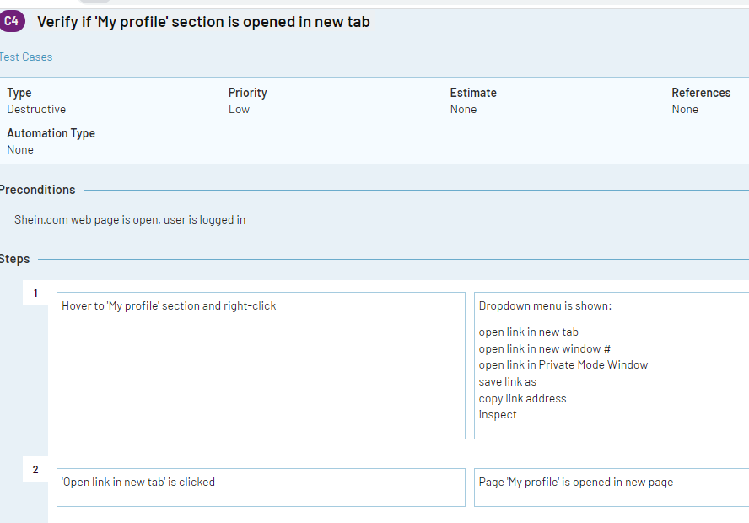

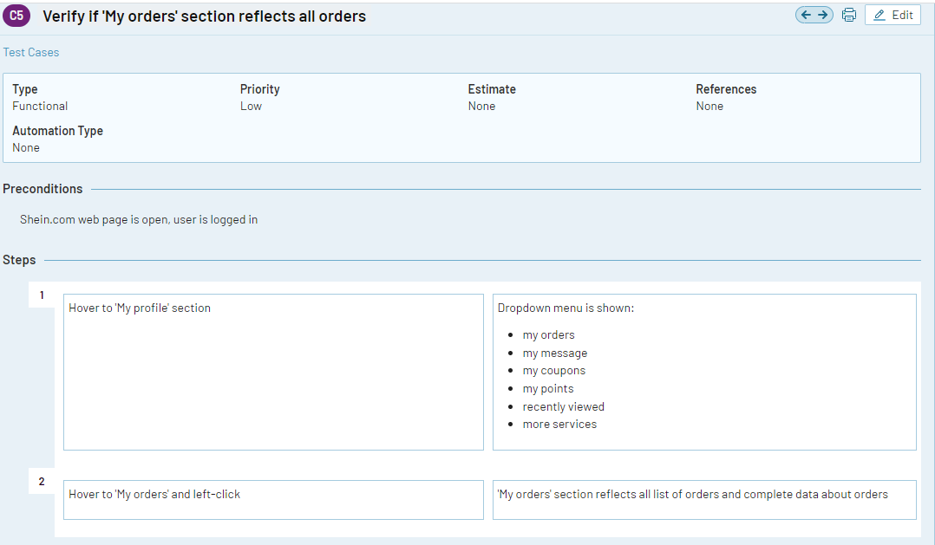
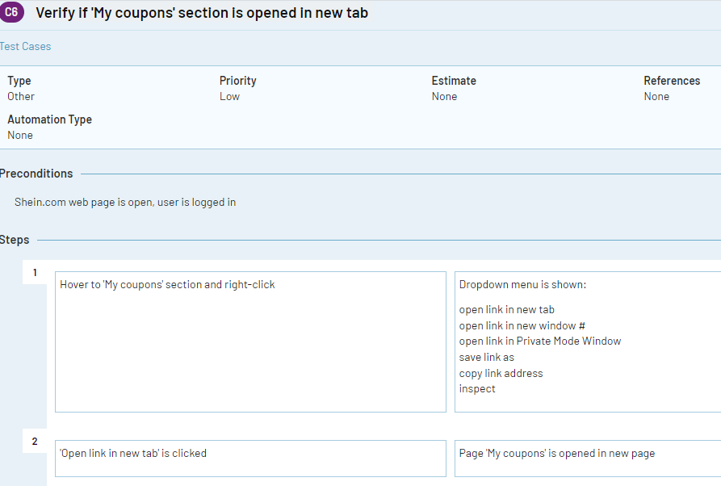

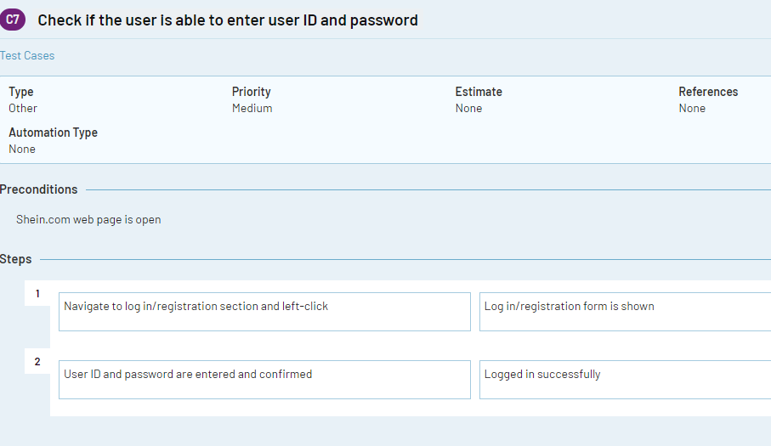
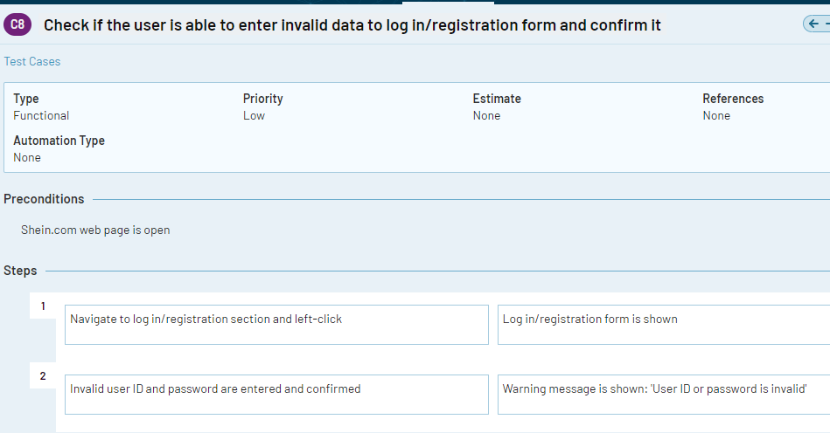
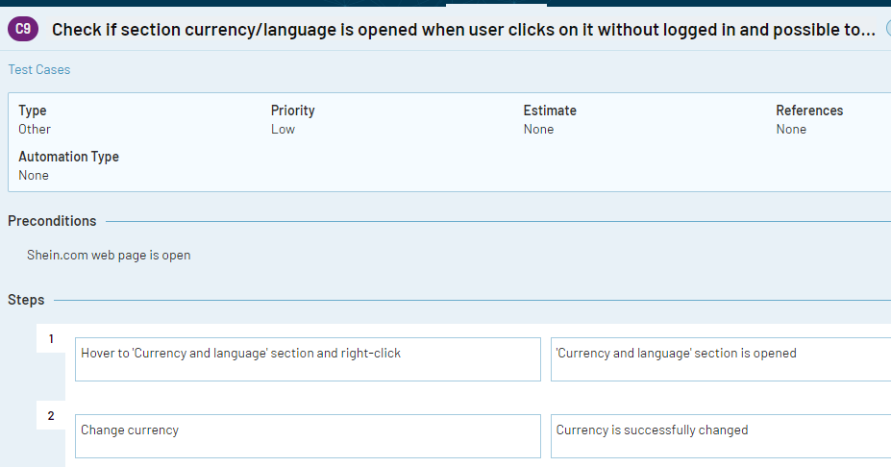

Founded issues and bugs

1.
Priority: low

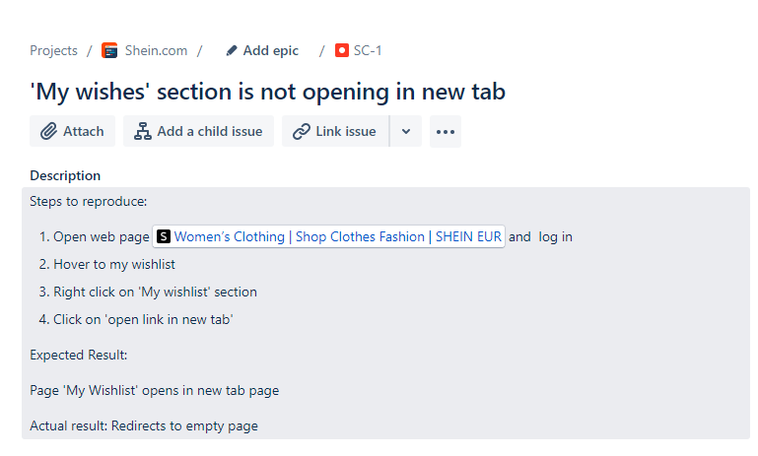

2.
Priority: low
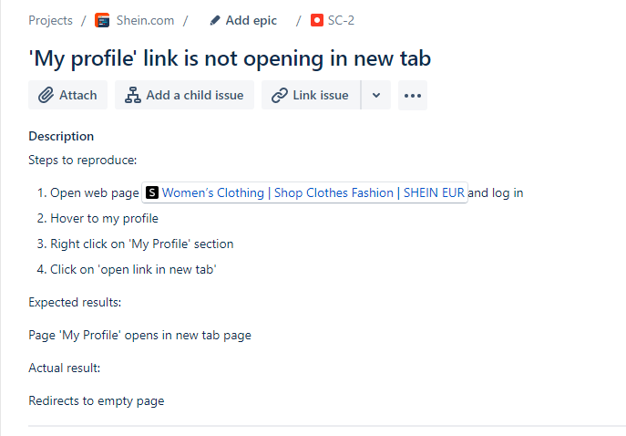
3.
Priority: low
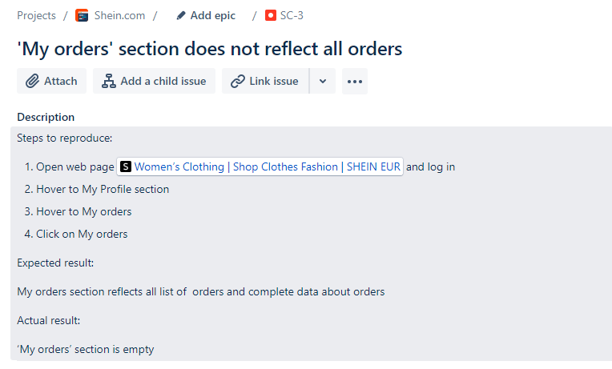

4.
Priority: low
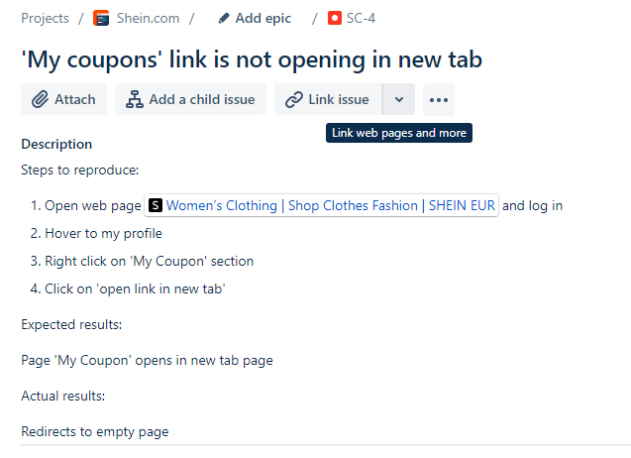

Testing tools

In this testing work I have used two tools: Test Rail for writing test cases and jira to write bug reports.

Improvements

I would like to suggest few improvements to ‘shein.com’ e-commerce web page to make it more convenient and qualitative.

- Changing currency and language when user is not logged in

User can’t open this section if does not log in. As the advertisement is overlapping on this section so user is not able to click on it. But after user is log in, advertisement disappears. So to make this site more user friendly I would suggest to place advertisement lower than ‘currency and language’ section.

- Closing video ad when user is not logged in

User can’t close the video ad if does not log in. On the bottom of home page there is video ad, when user clicks, it starts playing. But there is no closing options for this video. To close it, user should close whole site and open it again. So to make this site more comfortable I would suggest to add closing option to video ad.

- Data visibility in password field

When user opens password field and starts entering data there are not asterisk or bullet signs which makes entered data visible. It is essential function as makes using web page more comfortable. If user makes mistake in password this sign shows where exactly mistake is and lets user to fix it faster than deleting all password and enter again.

Test Design Techniques:

In this project I have used only Functional testing types like: Smoke Testing, Localization Testing. I have used smoke testing to check main functionalities of web page and if expected results are met to actual results. Also localization testing to check if web page crashes if I change language and how it functions.

Reflection

Implementation of this project was great experience for me. Creating it from the beginning on my own and with trainer’s advice made me confident and calm. As I understood how to handle each section and purpose. Of course, I had mistakes but they made me even better.

